**INFORMATION**

**NAME: Shyam Sunder Sharma**

**PASSPORT SIZE PIC:** 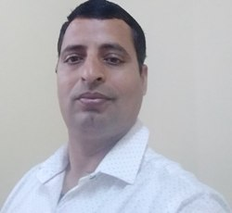

**Highest Qualification: MCA**

**Designation: Lab Assistant**

**LAB No. Assigned: CP07**

**Email Id:** [**sssharma.it@jecrc.ac.in**](mailto:sssharma.it@jecrc.ac.in), sssharma77@gmail.com

**Experience: 10 Years**